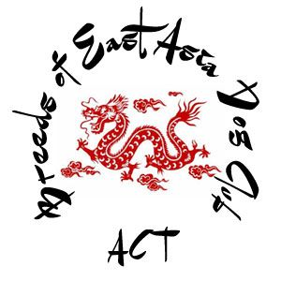

Akita, Chow Chow, Chinese Crested, Japanese Akita, Japanese Chin, Japanese Spitz, Lhasa Apso, Pekingese, Pug, Shar Pei, Shiba Inu, Shikoku, Shih Tzu, Siberian Husky, Tibetan Mastiff, Tibetan Spaniel, Tibetan Terrier.

Application for Membership

2025-2026

Name _____________________________________________________________________

Address ___________________________________________________________________

Suburb ______________________________ State ___________ Post code ___________

Email _______________________________ Contact Phone No_____________________

Prefix ______________________________

Dogs ACT or other controlling body Membership Number ________________________

Date:___________________

Membership Fees

Single: $25.00 Dual: $45

(Dual membership available to 2 persons living at the same address)

Please send cheque or money order made out to the club to;

The Secretary - 5 McCaw Place, Calwell ACT 2905

Or Bank Deposit

Breeds of East Asia Dog Club Inc.  **Bendigo Bank - BSB** 633-000 **Account** 158298216 (use name as reference)



.

Visit and Like our Facebook page to receive news from the club